**Title: Add title**

# Authors: Shyamolina Ghosh1 and James D. Bever2

# Authors Affiliations:

1Department of Ecology and Evolutionary Biology, The University of Kansas, 1200 Sunnyside Avenue, Lawrence, KS, 66045, USA

2Department of Ecology and Evolutionary Biology, The University of Kansas, 1200 Sunnyside Avenue, Lawrence, KS, 66045, USA

**Corresponding Author:** James D. Bever; Department of Ecology and Evolutionary Biology, The University of Kansas, 1200 Sunnyside Avenue, Lawrence, KS, 66045, USA; [jbever@ku.edu](mailto:jbever@ku.edu)

**Notes communicate concise points, using either data or theory. However, like Articles, they present insights of broad general significance and interest. Notes are no more than 3000 words of text (not including the literature cited) and have no more than three figures and/or tables in print.**

**Abstract**

**Keywords**: preferential allocation, resource competition, species coexistence.

**Introduction**

**The Model**

In comparison to past work, we here present a better representation of plant-mycorrhizal community dynamics which involves all the four key variables, namely, plant’s preferentially allocated carbon *(Ca)* to mutualist, plant’s construction carbon *(Cc)* and both symbionts (mutualist *(M)* and non-mutualist *(N)*). Mutualists uptake C from plant and in return supply inorganic phosphorus to plant’s root whereas non-mutualists serve as a parasite to the host plant by taking only the resource carbon from the plant. Plants initially, therefore, invest their resource carbon to both types of fungi to recognize the beneficial one for them and then allocate their resources particularly to the mutualists. This preferential carbon-allocation depends on the fidelity *(f)* of the plant to the beneficial mutualists, which in turn depends on the spatial structure of AMF- hyphae, close morphological proximity of roots and nodules and the ability of plants to allocating resources preferentially to mutualists even in absence of spatial structures. It is considered that fidelity has a range in between 0 to 1, whereas *f = 0* means plant does not allocate preferentially to any specific symbiont at all and *f = 1* means plant selectively allocate carbon to mutualist only. Both symbionts compete with each other to get advantage on the resources and mutualists have to pay a cost *(s)* due to mutualism which can reduce its maximum growth rate. Thus, plant-mycorrhizal communities are important in stabilizing ecosystem function, C-sink in soil and sustainable agriculture.

From our model as represented by Equations (1 - 4), we have derived the condition for co-existence of both symbionts and got the parameter range for fidelity *(f)* and cost *(s)*. The model is represented as follows;

| $$\frac{{dC}_{a}}{dt}=1-P_{s}-C_{a}F\left(M,N\right);F\left(M,N\right)=u\left[\frac{M}{K_{c}+M}\right]\left[\frac{M/{\left(M+N\right)}}{1-f+f\left[M/{\left(M+N\right)}\right]}\right]$$ | (1) |
| --- | --- |

|  | (2) |
| --- | --- |

|  | (3) |
| --- | --- |

|  | (4) |
| --- | --- |

All the terms and parameters are described in Table 1. Equation (1) represents the rate of change of allocated carbon which decreases with increasing phosphorous availability *(Ps)* in the soil. Again, as mutualists colonize the plant roots more effectively, then their efficiency needs less investment of allocated carbon by the plant. The function *F(M,N)* in Equation (1), which will eventually saturate at higher density of mutualists, depicts this scenario as shown in Figure 1 *(A)*. Equation (2) and Equation (3) show though per capita growth rate of mutualist and non-mutualist decreases with same death rate (d), their maximum growth rate *(bmax)* are affected differently. Though fidelity *(f)* gives the advantage to mutualist still it has to pay an energetic cost *(s)*. Equation (4) demonstrates a constant source of supplied resource *(ϕ)* for construction carbon *(Cc)* gets depleted eventually with increasing total symbiont-density and the density of construction carbon itself.

For finite equilibrium values of mutualist and non-mutualist (i.e., when $\hat{M},\hat{N}≠0$), we set both equation (2) and (3) equal to zero and get the following two equations for mutualist and non-mutualist, respectively;

| $$\hat{C_{aM}}=-\hat{C_{cM}}+\frac{K_{M}d}{b_{max}\left(1-s\right)-d}$$ | (5) |
| --- | --- |

|  | (6) |
| --- | --- |

Equation (5) indicates zero net growth isocline (ZNGI) for mutualist as a straight line with slope of -1 (see solid line in Figure 1 *(B)*) and equal intercepts on allocated carbon and construction carbon axes as *CcM* = CaM\**. Equation (6) represents the ZNGI (see dashed line in Figure 1 *(B)*) for non-mutualist with a much steeper slope of *-1/(1-f)* as *0 <f <1*. The ZNGI for non-mutualist has unequal intercepts on their respective axes as *CcN* = (1-f)CaN\**. If these two straight lines intersect for a set of positive finite values *(Ca, Cc)* then both mutualist and non-mutualist will co-exist for any initial supply line of carbon resources. We represent the condition for co-existence of both symbionts as follows;

| $$1<{C_{aN}^{*}}/{C_{aM}^{*}}< 1/{(1-f)}$$ | (7) |
| --- | --- |

Furthermore, all the densities of allocated carbon *(Ca)*, construction carbon *(Cc)* and both symbionts *(M, N)* should always be non-negative for practical purpose which throws some additional restrictions as follows;

| $$s<1-\left(d/{b_{max}}\right), d< b_{max}$$ | (8) |
| --- | --- |

In the next section we will show three different cases for different possible combination of Equations (7) and (8).

**Results**

We solved numerically Equations (1) to (4) by classical 4th order Runge-Kutta method with time increment Δ*t = 0.01* and initial values for *(Ca , Cc , M, N)t=0* *= (0.1, 0.1, 0.5, 0.3).* We set parameters *Ps = 0.3, u = 0.4, bmax = 0.8, d = 0.5, s = 0.3, g = 0.2, Kc = 5, KM = 10, KN = 30* throughout our study. For different combination of fidelity *(f)* and constant resource density of construction carbon stored in the plant *(ϕ)*, we demonstrated symbionts could show different dynamics. Need explanation what is the biological meaning of different fidelity and phi ? Do they plant specific or symbionts specific? For *f = 0.2* and *ϕ = 5*, mutualist and non-mutualist ZNGI did not intersect (see Figure A1 *(A)*) and *(CaN* / CaM* ) <* 1 violating the condition for coexistence (Equation 7), therefore destabilizing the system indicated by the numerical divergence in Figure A1 *(B)* and *(C).* Even if for very high supply of *ϕ*, for *f = 0.2* the system would never be able to show stable co-existence.

For relatively higher fidelity (*f* *= 0.3)*, two ZNGI for mutualist and non-mutualist intersect at positive phase-space of allocated and construction carbon (Figure 2 *(A)*) indicating that both symbionts did co-exist for this situation. We varied the constant source of construction carbon *ϕ* from a lower input (=*5)* to a higher input (=*25*) and found that allocated and construction carbons reached the same equilibrium state as shown in Figure 2 (*B)* for *ϕ=5* and in Figure 2 *(D*) *ϕ=25,* where construction carbon always maintained higher proportion than allocated carbon. (Need explanation why?) Though for lower *ϕ,* mutualist dominated over co-existing non-mutualist (Figure 2 *(C)*)but with increasing *ϕ* non-mutualist attained greater proportion than mutualist (Figure 2 *(E)*). (Need explanation why?)

**Discussion**

**Tables**

Table 1: Description of model terms.

|  |  |
| --- | --- |
| Model Term | Definition |
| *Ca* | Density of allocated carbon that is discriminately and preferentially allocated to mutualists |
| *Cc* | Density of construction carbon that is allocated indiscriminately to symbionts to construct the site of symbiosis |
| *M* | Density of mutualist symbiont |
| *N* | Density of non-mutualist symbiont |
| *F(M,N)* | Function representing phosphorous uptake by both symbionts |
| *Ps* | Phosphorus availability in the soil |
| *u* | Phosphorous uptake per unit of preferentially allocated carbon received by mutualists |
| *f* | Fidelity of plant allocation to mutualist symbionts |
| *s* | Cost of mutualism |
| *bmax* | Maximum growth rate of symbionts |
| *d* | Constant death rate |
| *Kc* | Half-saturation constant for allocated carbon |
| *KM* | Half-saturation constant for mutualist symbiont |
| *KN* | Half-saturation constant for non-mutualist symbiont |
| *g* | Rate at which construction carbon is allocated to both symbionts |
| ϕ | Source density of construction carbon stored in the plant |

**Figures**

(A)  
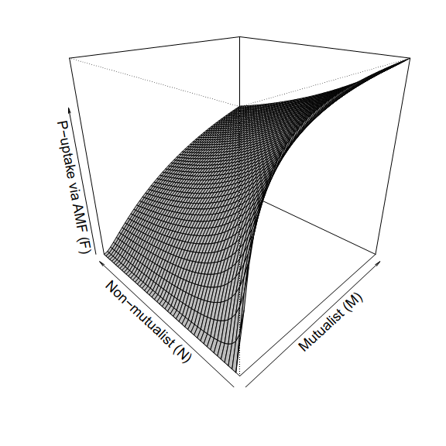

(B)  
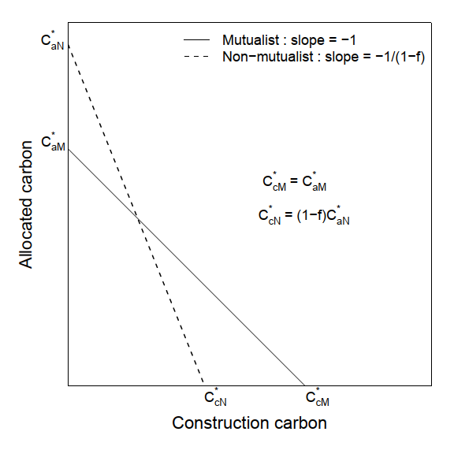

Figure 1: *(A)* P-uptake via mycorrhizal fungi *F(M,N)* as a function of densities of mutualists (M) and non-mutualist (N). M and N vary over range (0,100). *(B)* Schematic diagram depicting the condition for stable co-existence between both symbionts.

Figure 2:

(B)  
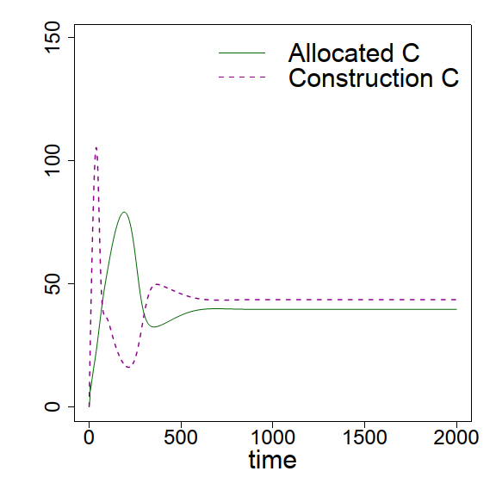

(C)  
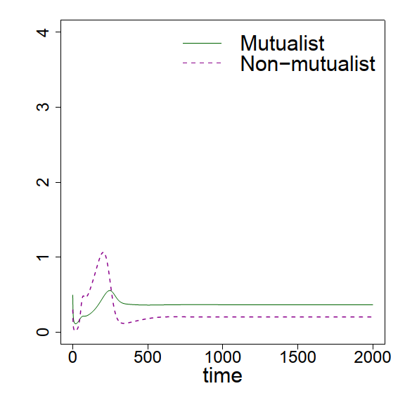

(D)  
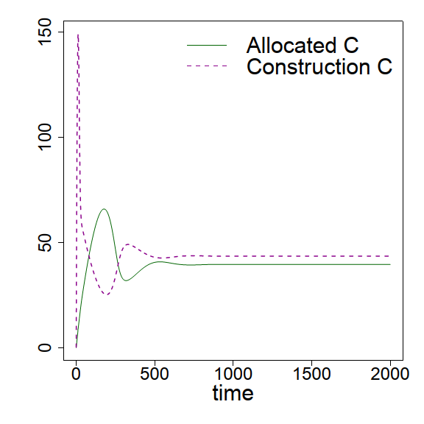

(E)  
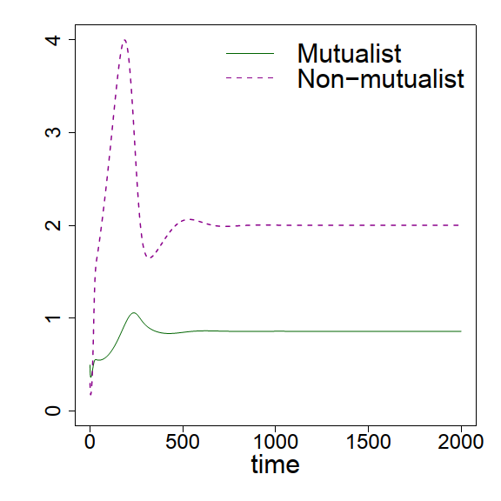

(F)  
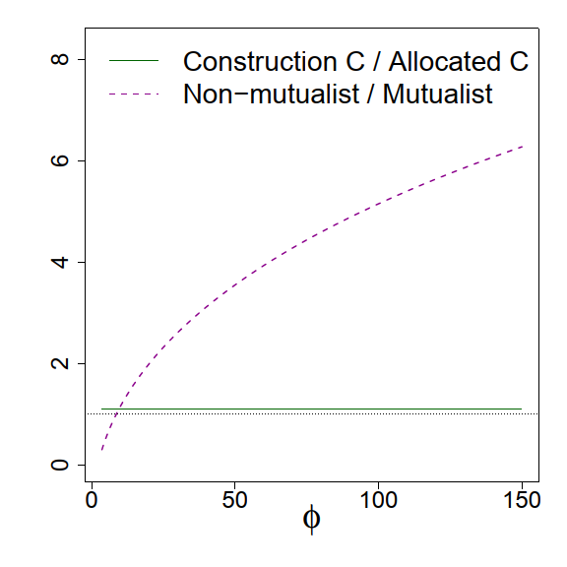

(A)  
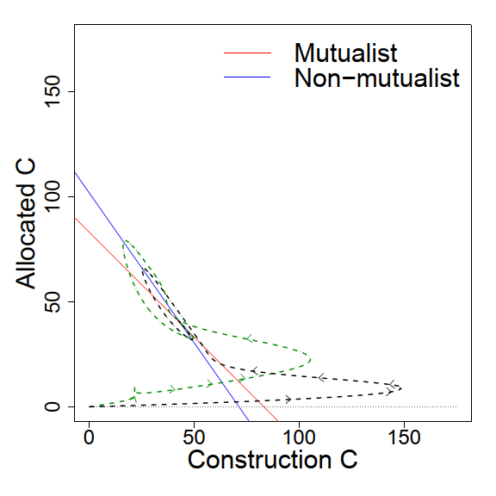

**Acknowledgements**

**Literature Cited**

Bever, J.D. (2015) Preferential allocation, physio-evolutionary feedbacks, and the stability and environmental patterns of mutualism between plants and their root symbionts. *New Phytologist*, **205**, 1503–1514.

**Appendix:**

(A)  
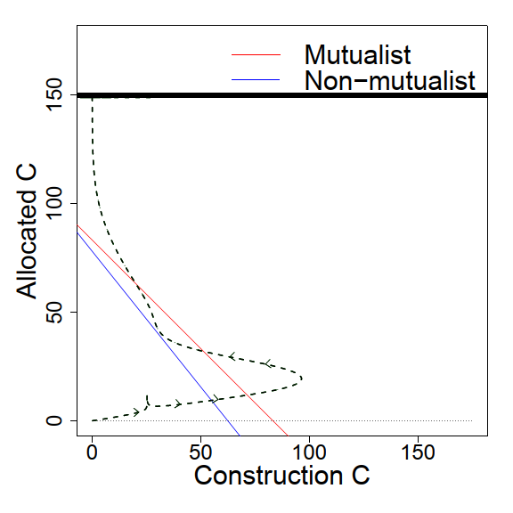

(B)  
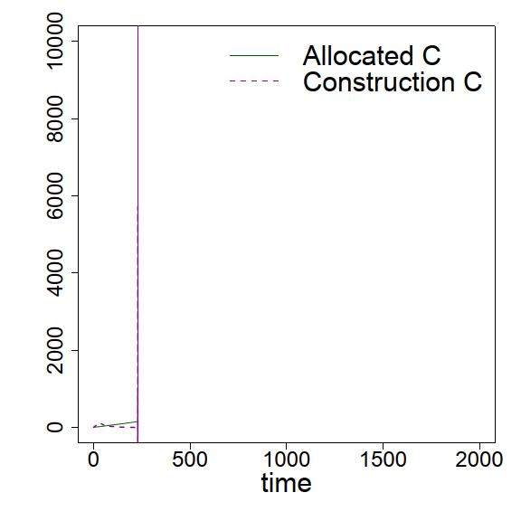

(C)  
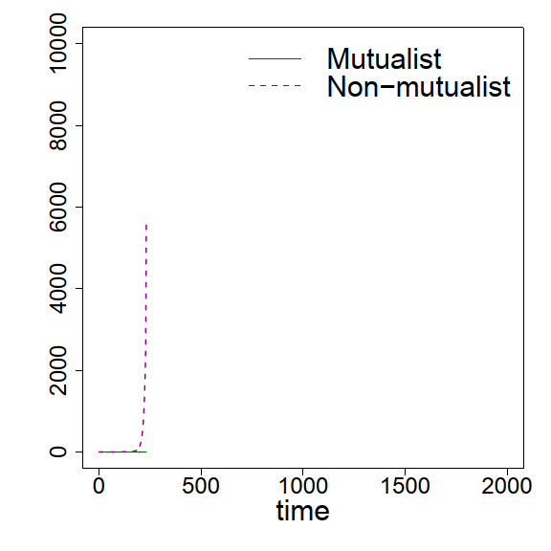

Figure A1:

(E)  
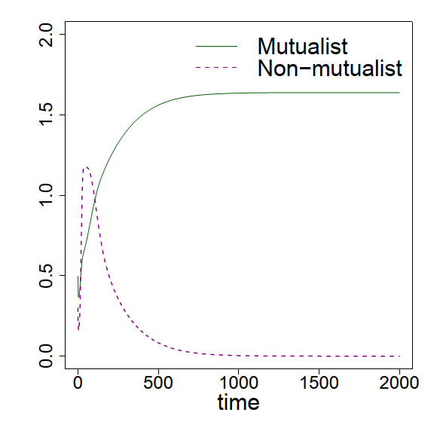

(D)  
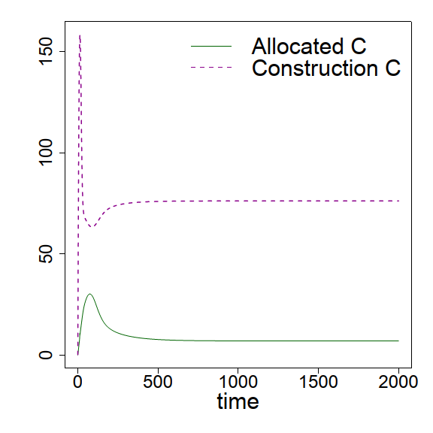

(C)  
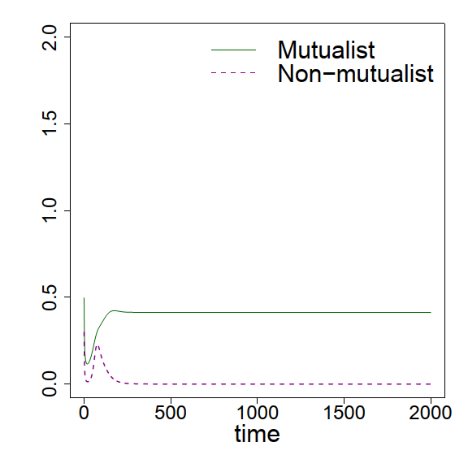

(B)  
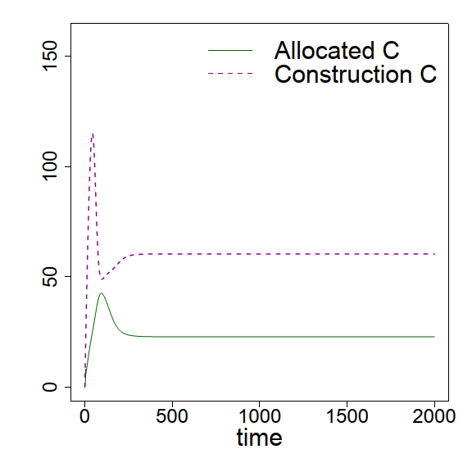

(A)  
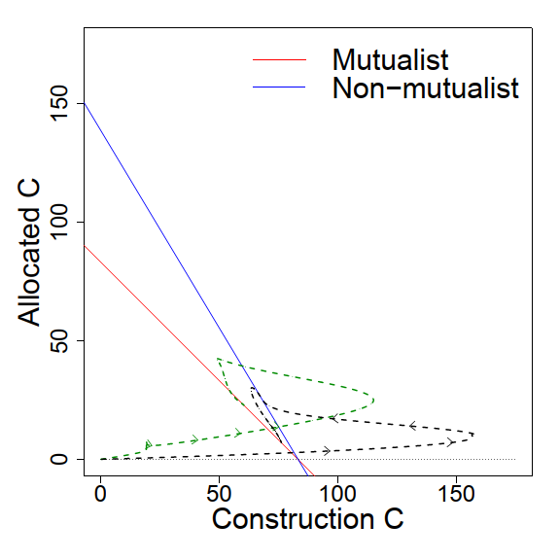

Figure A2: